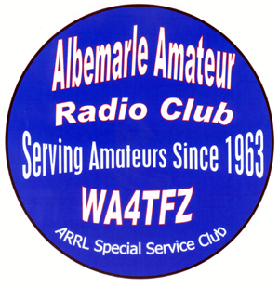

**Albemarle Amateur Radio Club**

**PO BOX 6833  
CHARLOTTESVILLE, VA 22906**

**www.albemarleradio.org**



WW

An American Radio Relay League Affiliated Club: WA4TFZ & W4DO

**TPresidents**

Edward L. Berkowitz

N3US

**Vice President**

Robert E. Pattison

K4DU

**Secretary**

Stephen M. Kramer

KN4CJI

**Treasurer**

Donald H. Eason, Jr

N4UVA

**Directors**

John H. Porter

KK4JP

Public Service

James C. Owen, III

K4CGY

Estate Services

John R. (Rick) Oliver

W3KDR

Education

William D. Pond

NØWP

Technical

Alexander J. Miller

KE4AJM

Fund Raising

Paul M. McKee

AK4OH

Public Relations

**Webmaster**

John H. Porter

KK4JP

**ARES/RACES Liaison**

Michael R. McPherson

KQ9P

**Club Stations Trustee**

James C. Owen, III

K4CGY